**Police Officer (Posting and Promotion) Guidance: How to complete an application form**Application forms are a structured way to gather information about a candidate against specific requirements for a role. The aim is to provide the most convincing evidence of how you meet those requirements**.**

Know the job you are applying for (role / rank requirements) In order to provide evidence of how you meet the requirements of role or rank, it is important to ensure that you are clear about what these are prior to starting your application.

**Useful resources**

**Role summary / profile** – This will normally be detailed within the accompanying advert.

[**Policing Professional Profiles**](https://profdev.college.police.uk/professional-profiles/profiles/) – Provided by the College of Policing, the profiles define the expectations and accountabilities of all for police officer ranks. They articulate the skills and professional standards, competencies and behaviours for policing on a national basis.

[**Core skills | College of Policing**](https://www.college.police.uk/career-learning/support-for-career-development/core-skills) **-** Information to help you to understand the core skills needed for professional development

[**Leadership standards | College of Policing**](https://www.college.police.uk/career-learning/leadership/leadership-standards) - These standards set a benchmark for the leadership knowledge and understanding, skills, attitudes, behaviours and performance expected of police officers operating at these stages.

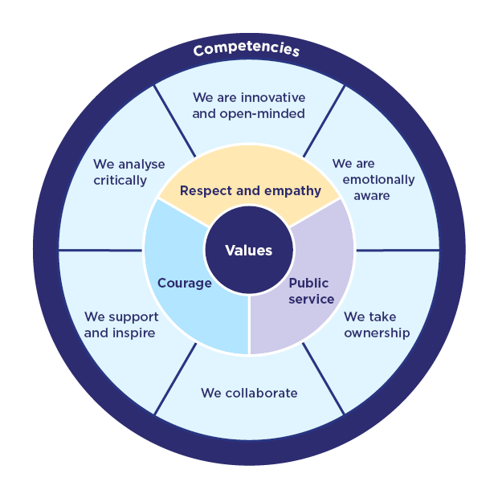Understand the assessment framework (CVF)The application may be assessed against the [competency and values framework (CVF)](https://www.college.police.uk/career-learning/competency-and-values-framework). The framework provides clear expectations for everyone working in policing.   
  
**Values:** Values are beliefs which are important to us as individuals, and which motivate particular behaviours and actions. Policing is a deeply ethical profession.  
  
**Competencies:** Competencies are skills, abilities and practical behaviours that contribute to effective job performance. 

The CVF describes the behaviours required by you, to be effective in your role and uphold the [Code of Ethics](https://www.college.police.uk/ethics/code-of-ethics), but it also plays a significant role in the recruitment, assessment, and development of officers and staff at every level.  
  
How is the CVF used within an application form?  
Each competency and value includes a description and an explanation of why it is important, and a list of example behaviours. These are examples and are not intended as a comprehensive list of all behaviours under the competency or value. There will be many ways of demonstrating the behaviour that falls within the competency or value area, as defined by the description.   
  
The most common way of using the CVF as an assessment tool is:

* **No specific question** i.e. provide X amount of words to demonstrate your competence of a selected competency or value. For example, if the competency is ‘we are emotionally aware’, you would expect assessors to be looking for an answer that focuses on understanding yourself and others and should tailor your response to that theme / context.
* **Specific question aligned to element from the CVF** i.e. The competency or value selected will indicate to you what is being assessed and how to focus your answer to the question.

**Example of how the CVF sets the context for a question**  
‘Please provide evidence of how you deliver performance objectives effectively’   
  
When aligned to the competency ‘*we collaborate’*, you should expect to frame your response in such a way that draws on the themes of working with others / the importance of collaboration in delivering objectives. Whereas, if the question was aligned to *‘we analyse critically’*, you may focus more on how your decision making and analysis of issues contributed to performance goals.   
  
The competency / value will set the context for your answer, but it is very important that if when a specific question is asked, you provide evidence to this rather than general responses to the CVF.

The questions may be either a past behaviour-based question or a future-focused question. This helps to provide a good balance between what you have done and how you would apply your experience, as well as an opportunity to demonstrate your wider thinking.

What should I consider?   
  
Take time to understand the CVF competencies and values and reflect on how you have used them and demonstrated them in your own work.  
Each competency is split into 3 levels, ensure you understand which level is being assessed:

Level 1: Practitioner

Level 2: Supervisor / middle manager

Level 3: Senior manager / executive.

Remember, it is not necessary to demonstrate evidence of every single indicator / behaviour of a competency or value. Instead, use the CVF to highlight effective behaviours that you demonstrated but ensure that they are tailored to what you did and your considerations.   
  
Merely repeating the behaviours or wording will not score well, so try to focus on **how** you demonstrated the behaviours.

Structuring your response   
  
It is common for application include a word count, where you are limited to a specific number of characters or words for each question / criteria. Therefore, it is important to ensure that your response is well thought out and does not provide anything that isn’t needed / relevant to the question. A structure or framework can help you achieve this.

The STAR and CARL techniques are two popular frameworks used to structure answers:  
  
  
  
It is helpful to check and refine your responses. Sometimes a fresh pair of eyes can be useful – ask a trusted colleague or friend to check them and give you honest feedback. Is your response compelling and at the right level? Do you answer the question? Is it clear what you did and does all this relate to the values, competencies and level you are trying to show?

**C A R L   
  
Context:**Briefly describe the context of you experience

**Action:**Explain what actions you took: What did you do? What else happened (other actions)? Why did you choose this action?

**Results:**Explain what happened as a result of your actions: What are the implications of your actions on others/similar situations in the future? Is there a way you could improve your results or actions?

**Learning:**Identify what you have learned: What did you learn from the experience? Would you do the same thing again or change something?

**S T A R**   
  
**Situation**: Briefly describe the specific event or situation. This should be a short description to set the context.

**Task**: Briefly explain what you had to do. What were you trying to achieve from the event or situation? What were the success criteria?

**Action(s):** Here is where you can really explain how you displayed the relevant behaviours and understanding: what did you do? How did you do it? Why did you do it that way? What skills did you use?

**Results:** Summarise the results of your actions. What was the outcome?

General tips

* You should read the questions fully and choose your examples very carefully to ensure that they answer the question posed.
* Make a plan – if you are unsure where to start, have a go at jotting down some thoughts for each question before starting to expand on each point.
* Give yourself plenty of time and avoid waiting until the week of the deadline.
* Refer back to the CVF and information on the role you are applying for.
* Show evidence at the relevant level required.
* Avoid using jargon, slang terms or abbreviations.
* Challenge yourself on whether you are demonstrating **how** you evidenced that competency or value. Explain what you did and why.
* You must adhere to the word limits for each question, so avoid storytelling and unnecessarily explaining situations. Any content over the word count will be removed.
* The application must be your own work. Applications that contain any material that is not original or accurate may be withdrawn.

Frequently Asked Questions

**How recent does my evidence need to be – does it have to be from the last 12 months?**   
  
There is no set rule, but we always recommend that you pick your very best and most recent evidence. It is worth bearing in mind that priorities, processes and the policing environment changes over time – something that was relevant 3 years ago, may not have the same weight or importance now.

**Can I ask someone to read through and check my application form?**

Yes, it is beneficial to seek the views from another party who is objective. Be mindful of who and how many people you ask for support, as too many views can be confusing. It is important to ensure that the person you ask for support has an up to date knowledge of the process and assessment framework. Please note, another person cannot write your application